Problem Solving with Surds
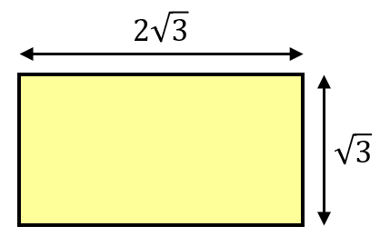
Find the area and perimeter of these rectangles.
(a)

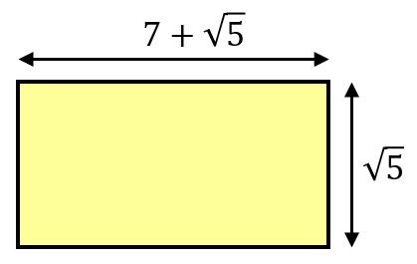
(b)

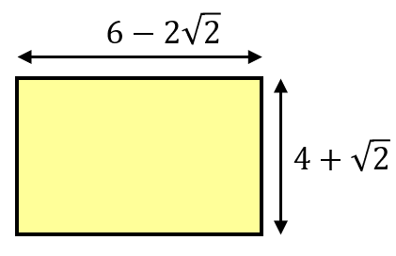
(c)

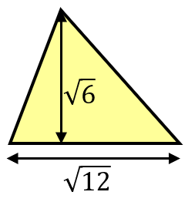
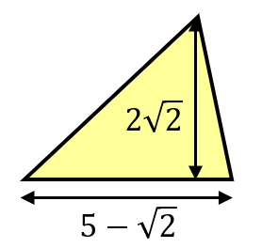
Find the area of these triangles.
(a) (b)

(a) Given that $\left(3+\sqrt{a}\right)\left(4+\sqrt{a}\right)=17+b\sqrt{a}$ find the values of $a$ and $b$.
(b) Given that ${(5-\sqrt{x})}^{2}=y-20\sqrt{2}$ find the values of $x$ and $y$.

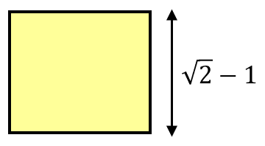
(a) The perimeter of this rectangle is $8\sqrt{2}$. Find the area of the rectangle.

Problem Solving with Surds
Find the area and perimeter of these rectangles.
(a)

(b)

(c)

Find the area of these triangles.
(a) (b)

(a) Given that $\left(3+\sqrt{a}\right)\left(4+\sqrt{a}\right)=17+b\sqrt{a}$ find the values of $a$ and $b$.
(b) Given that ${(5-\sqrt{x})}^{2}=y-20\sqrt{2}$ find the values of $x$ and $y$.

(a) The perimeter of this rectangle is $8\sqrt{2}$. Find the area of the rectangle.

