Statistics and Probability Revision |  |  |  |  |  |  | 1
(a) | (b) | (c)
A shop sells four types of ice cream – vanilla, chocolate, strawberry and banana. Kajal chooses a type of ice cream at random. On the probability scale, mark with a cross the probability that Kajal chooses vanilla ice cream.  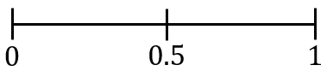 | A bag contains 7 red counters and 3 white counters. A counter is chosen from the bag at random. Circle the word that describes the probability of choosing a green counter.  Impossible  Unlikely  Evens  Likely  Certain | 20 students choose their favourite colour. The results are listed below. Complete a frequency table to show the results.
 |  | blue | red | black | red | Colour Tally Frequency  Blue  Red  Black  Yellow  White
 |  | yellow | red | blue | blue
 |  | white | black | white | red
 |  | red | yellow | blue | white
 |  | white | red | red | blue
(d) |  | (e) |  |  |  | (f)
The pictogram shows the number of different species of bird that visited a garden. |  | Here are five cards, each with a number on it.  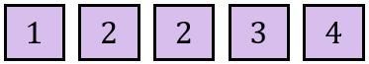  A card is chosen at random.  (i) Work out the probability that the number on the card chosen is 2.  (ii) Work out the probability that the number on the card chosen is less than 10. |  |  |  | Ismail is making a packed lunch, made up of a sandwich and a snack. He can choose one item from each list.  Sandwich Snack  Cheese (C) Fruit (F)  Tuna (T) Biscuit (B)  Ham (H) Rice Cakes (R)  Write down all the possible combinations Ismail can choose.
Magpie  Starling  Pigeon  Chaffinch  Blackbird  Key: represents 4 birds | (i) One species of bird visited the garden 10 times. Which one?  (ii) 9 blackbirds visited the garden. Show this information on the pictogram.  (iii) Work out the total number of magpies and pigeons that visited the garden.

