Crack the Code | Calculating with Bounds

A | The length and width of a rectangle are measured to the nearest metre as $6 m$ and $5 m$. Find the lower bound of the area of the rectangle. | B | A coin is weighed as $30 g$ to the nearest $5 g$. Find the upper bound of the weight of $10$ coins.
C | The three sides of a triangle are $5 cm$, $8 cm$ and $11 cm$, all measured to the nearest cm. Find the upper bound of the perimeter of the triangle. | D | A dog weighs $26 kg$ to the nearest $kg$. Its puppy weighs $6.5 kg$ to the nearest $0.5 kg$. Find the lower bound of the difference between their weights.
E | A car travels $82 km$ correct to the nearest $km$, in $1.5$ hours correct to the nearest $0.1$ hour. Find the lower bound of the speed in $km/h$. | F | The area of a square is measured as $60 {cm}^{2}$, correct to $1$ significant figure. Find the upper bound of the length of the side of the square.
G | The formula $A=\frac{1}{2}ab\sin{C}$ is used to find the area of a triangle.  $a=12 cm, b=9 cm$ and angle $C$ is $72°$, all correct to 2 significant figures. Find the upper bound of the area $A$. | H | The density of a wooden block is measured as $1.8 g/{cm}^{3}$ to the nearest $0.1 g/{cm}^{3}$and its volume as $40 {cm}^{3}$ to the nearest $5 {cm}^{3}.$Find the lower bound of the mass of the wooden block in $g$.
I | 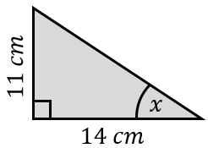  The lengths of the right-angled triangle shown are measured correct to $2$ significant figures. Find the lower bound of the size of angle $x$. | J | 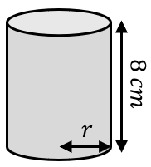  The cylinder shown has a volume of $400 {cm}^{3}$, correct to the nearest $10 {cm}^{3}$. Its height is $8 cm$ correct to $1$ significant figure. Find the upper bound of the radius of the cylinder.
To get the three-digit code, add all your answers together and round to the nearest integer.

