Non-Linear Simultaneous Equations

(a) Solve algebraically $xy=4$
$y=x+3$
(b) Solve algebraically $xy=-8$
$x+y=2$
(c) Solve algebraically $xy+12=0$
$x=2-2y$

(a) Solve algebraically $y=\frac{3}{x}$
$2x=y-1$
(b) Solve algebraically $y=\frac{4}{x}-2$
$x=4y+8$
(c) Solve algebraically $y=\frac{4}{x}+x$
$x+y=6$

(a) Solve algebraically $x^{2}+xy=20$
$x=4y$
(b) Solve $x^{2}+y^{2}-xy=16$
$x+y=4$
(c) Solve $x^{2}-y^{2}=4+xy$
$y=2x-6$

The diagram shows the graphs of
$y=x+\frac{9}{x}$ and $x+y+11=0$. Find the coordinates of the points of intersection.
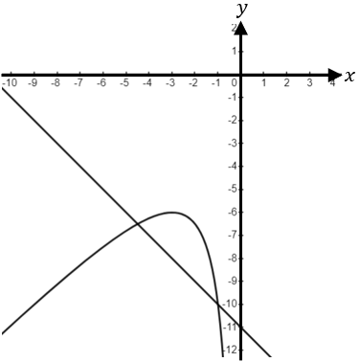
Non-Linear Simultaneous Equations

(a) Solve algebraically $xy=4$
$y=x+3$
(b) Solve algebraically $xy=-8$
$x+y=2$
(c) Solve algebraically $xy+12=0$
$x=2-2y$

(a) Solve algebraically $y=\frac{3}{x}$
$2x=y-1$
(b) Solve algebraically $y=\frac{4}{x}-2$
$x=4y+8$
(c) Solve algebraically $y=\frac{4}{x}+x$
$x+y=6$

(a) Solve algebraically $x^{2}+xy=20$
$x=4y$
(b) Solve $x^{2}+y^{2}-xy=16$
$x+y=4$
(c) Solve $x^{2}-y^{2}=4+xy$
$y=2x-6$

The diagram shows the graphs of
$y=x+\frac{9}{x}$ and $x+y+11=0$. Find the coordinates of the points of intersection.

