Transforming Shapes
(a) | (b) | (c)
Translate the shape by $\left(\begin{matrix}3 \\ 4\end{matrix}\right)$  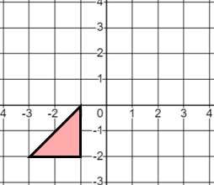 | Reflect the shape in the line $x=2$  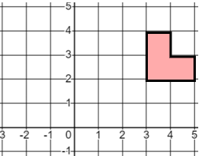 | Enlarge the shape by scale factor $2$ about the origin  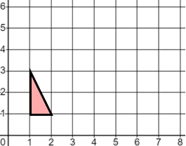
(d) | (e) | (f)
Rotate the shape by $180°$ about the point $(1, 0)$  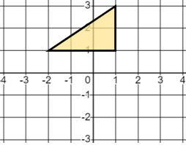 | Translate the shape by $\left(\begin{matrix}5 \\ -2\end{matrix}\right)$  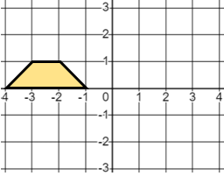 | Reflect the shape in the line $y=-1$  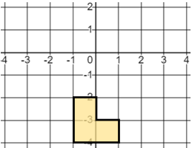
(g) | (h) | (i)
Translate the shape by $\left(\begin{matrix}-2 \\ -3\end{matrix}\right)$  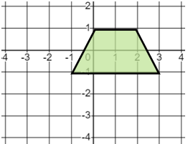 | Enlarge the shape by scale factor $3$ about $(-3, -1)$  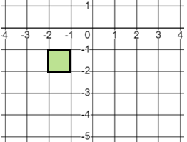 | Rotate the shape $90°$ clockwise about $(0, -2)$  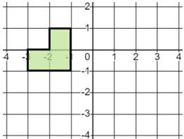
(j) | (k) | (l)
Enlarge the shape by scale factor $\frac{1}{2}$ about $(2, 2)$  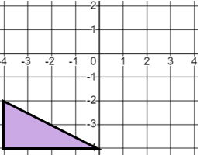 | Reflect the shape in the line $y=x$  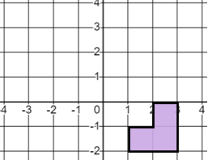 | Rotate the shape $90°$ anti-clockwise about $(-1, 0)$  