Pythagoras’ Theorem Worded Problems
(a) | (b) | (c)
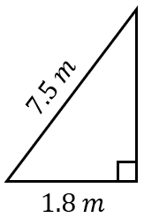  A ladder which is 7.5 m long, leans against a wall. The foot of the ladder is 1.8 m from the foot of the wall. How far up the wall does the ladder reach to 1 decimal place? | A ship sails 150 km west, then turns and sails 130 km south. How far from its original position is the ship now, to the nearest km?  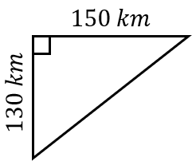 | 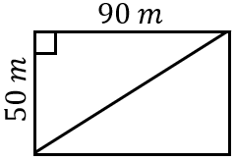  A football pitch is 90 m by 50 m. Find the length of the diagonal of the pitch to 1 decimal place.
(d) | (e) | (f)
A snail starts at point A and travels 75 cm east and then 60 cm north to point B. Find the direct distance from A to B.  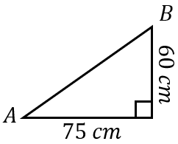 | 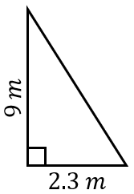  A ladder leans against a wall. The foot of the ladder is 2.3 m from the foot of the wall, and the ladder reaches 9 m up the wall. How long is the ladder, to 1 decimal place? | A farmer has a field in the shape of a trapezium, as shown. He wants to put a fence all the way around the field. How long will the fence need to be, to 1 decimal place?  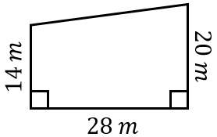
(g) | (h) | (i)
A netball pitch is 15 metres wide and 30 metres long. Find the length of the diagonal to 1 decimal place. | A bird flies from its nest 2 km due north, then 3.5 km due east. Find the distance of the bird from its nest after its flight. | A ladder of length 8.2 m leans against a wall. The ladder reaches 6.9 m up the wall. How far is the foot of the ladder from the foot of the wall?

