Shading Harder Graphical Inequalities
(a) | (b) | (c)
$$y≥-1$$  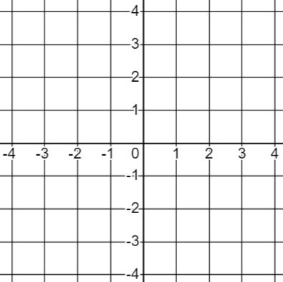 | $$x<2$$ | $$y>x$$
(d) | (e) | (f)
$$y≥0.5x-1$$ | $$x+y≤3$$ | $$-3≤y<2$$
(g) | (h) | (i)
$$-2≤x<3$$ | $$x≥0 and y<x$$ | $$x≥-1, y>0 and x+y<2$$
(j) | (k) | (l)
$$2<x<4 and-1≤y≤1$$ | $$y<2x, x+y≤4 and y>0$$ | $$y<x, y≥-2 and 2x+y<4$$

