Angles in Irregular Polygons
(a) | (b) | (c) | (d)
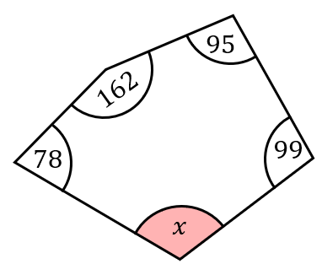 | 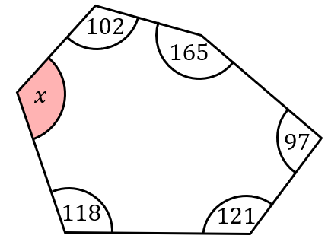 | 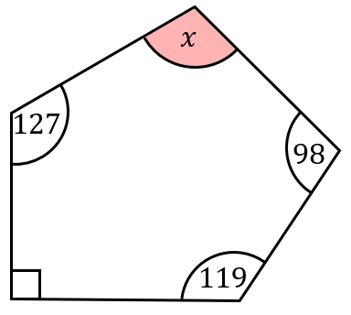 | 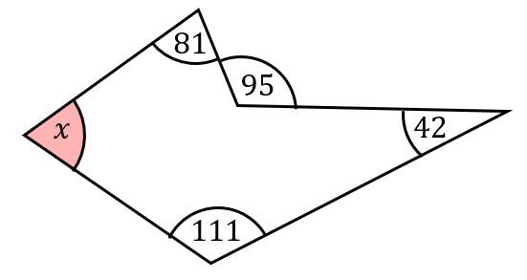
(e) | (f) | (g) | (h)
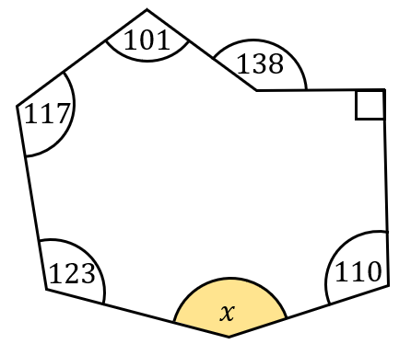 | 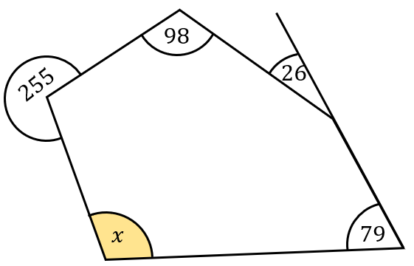 | 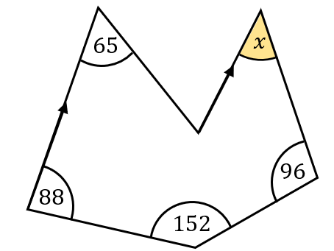 | 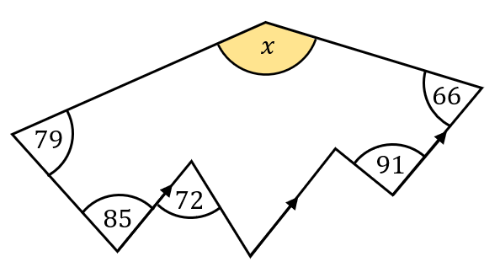
(i) | (j) | (k) | (l)
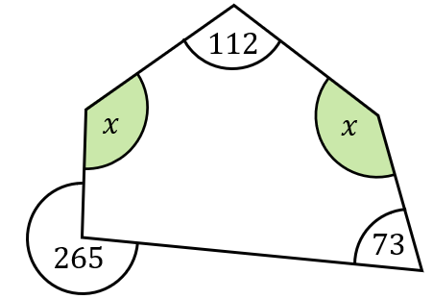 | 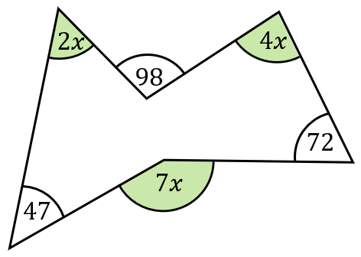 | An irregular pentagon has interior angles of $5x^{2}, 126°,$  $(10x+72°), 132°$ and a right angle. Find the value of $x$. | The interior angles in an irregular hexagon make up an arithmetic sequence with common difference of $12$. Find the size of the largest angle.

