Defining Vectors
(a) |  | (b) |  | (c)
The diagram is made up of nine congruent rhombuses.  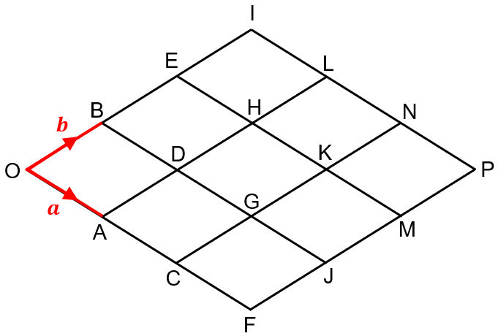  $\vec{OA}=a$ and $\vec{OB}=b$. |  | The diagram is made up of twelve congruent parallelograms.  $\vec{OA}=2c$ and $\vec{OD}=d$.  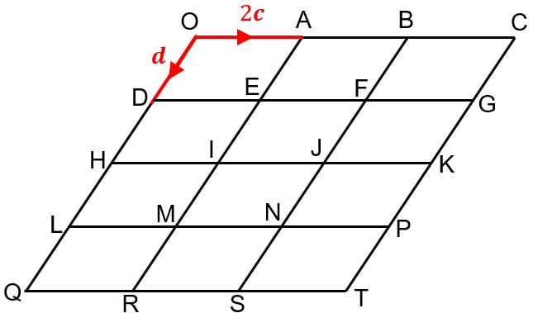 |  | The diagram is made up of nine congruent equilateral triangles.  $\vec{OB}=x$ and $\vec{OD}=y$.  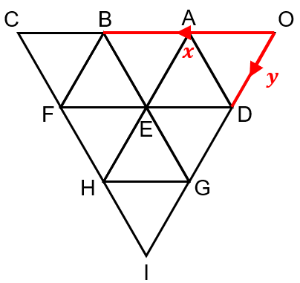
Define the following vectors in terms of $a$ and $b$. |  | Define the following vectors in terms of $c$ and $d$. |  | Define the following vectors in terms of $x$ and $y$.
(a) $\vec{OE}$ | (g) $\vec{OH}$ | (a) $\vec{EG}$ | (g) $\vec{MJ}$ | (a) $\vec{FD}$ | (g) $\vec{FO}$
(b) $\vec{OF}$ | (h) $\vec{DP}$ | (b) $\vec{BS}$ | (h) $\vec{QF}$ | (b) $\vec{HA}$ | (h) $\vec{CE}$
(c) $\vec{GJ}$ | (i) $\vec{IM}$ | (c) $\vec{KJ}$ | (i) $\vec{IL}$ | (c) $\vec{GH}$ | (i) $\vec{HI}$
(d) $\vec{MP}$ | (j) $\vec{MD}$ | (d) $\vec{RE}$ | (j) $\vec{HB}$ | (d) $\vec{OC}$ | (j) $\vec{BG}$
(e) $\vec{AO}$ | (k) $\vec{CB}$ | (e) $\vec{OF}$ | (k) $\vec{TE}$ | (e) $\vec{DB}$ | (k) $\vec{HD}$
(f) $\vec{LD}$ | (l) $\vec{NO}$ | (f) $\vec{JT}$ | (l) $\vec{KD}$ | (f) $\vec{OE}$ | (l) $\vec{IF}$

