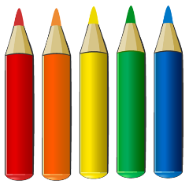
Pixel Picture

Rounding to Decimal Places

4.62 | 4.81 | 4.791 | 4.84 | 4.555 | 4.599 | 4.61
4.597 | 4.75 | 4.886 | 4.762 | 4.63 | 4.59 | 4.621
4.866 | 4.82 | 4.799 | 4.76 | 4.59 | 4.605 | 4.60
4.591 | 4.64 | 4.811 | 4.765 | 4.83 | 4.78 | 4.845
4.561 | 4.57 | 4.835 | 4.836 | 4.79 | 4.786 | 4.573
4.55 | 4.645 | 4.812 | 4.77 | 4.801 | 4.637 | 4.56
4.71 | 4.66 | 4.69 | 4.73 | 4.729 | 4.65 | 4.691

Colour blue all the numbers that round to 4.7 to 1 decimal place
Colour orange all the numbers that round to 4.87 to 2 decimal places
Colour yellow all the numbers that round to 4.8 to 1 decimal place
Colour black all the numbers that round to 4.89 to 2 decimal places
Colour pale blue all the numbers that round to 4.6 to 1 decimal place

