Theoretical Probability with Playing Cards
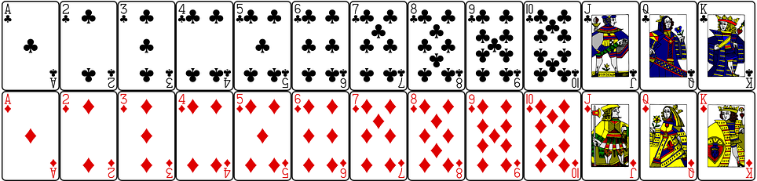 |  | 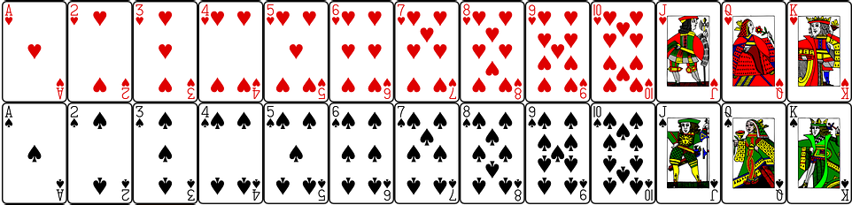
(a) | (b) | (c) |  | (d)
A playing card is chosen at random. What is the probability that it is a red card? | A playing card is chosen at random. What is the probability that it is a king (K)? | A playing card is chosen at random. What is the probability that it is the ace (A) of hearts? |  | A playing card is chosen at random. What is the probability that it is a spade card?
(e) | (f) | (g) |  | (h)
A playing card is chosen at random. What is the probability that it is not a diamond card? | A playing card is chosen at random. What is the probability that it is a 2, 3 or 4? | A playing card is chosen at random. What is the probability that it is a queen (Q) or a king (K)? |  | A playing card is chosen at random. What is the probability that it is a red card with a prime number on it?
(i) | (j) |  | (k)
A playing card is chosen at random. What is the probability that it is a red non-picture card? | Bruce chooses a card at random, looks at it and then replaces it in the deck. He repeats this 520 times. How many times would Bruce expect to see an ace? |  | Nadia chooses a card at random, looks at it and then replaces it in the deck. She repeats this 260 times. How many times would Nadia expect to see a red jack (J) or red queen (Q)?

