Solving Inequalities Graphically
Use the graph to help solve each of these linear and quadratic inequalities.
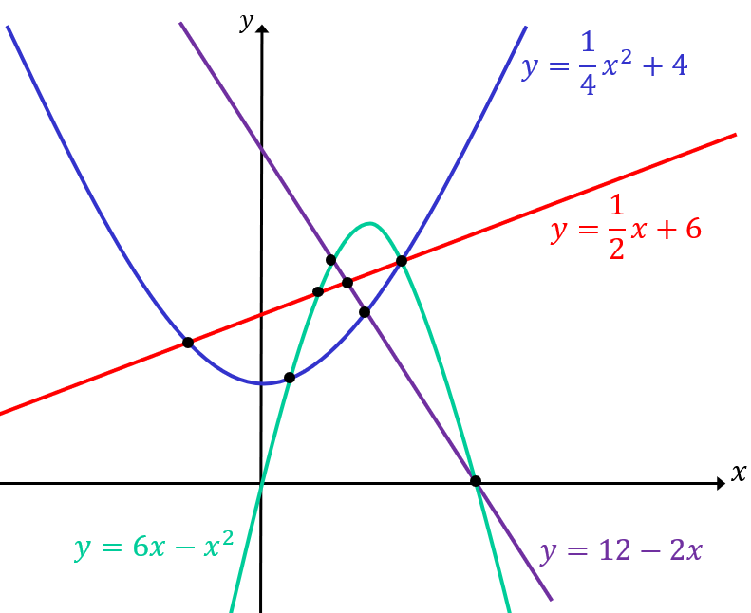 | (a) | (b)
 | $$12-2x>\frac{1}{2}x+6$$ | $$6x-x^{2}≤12-2x$$
€ | (d) | €
$$\frac{1}{2}x+6≤6x-x^{2}$$ | $$\frac{1}{4}x^{2}+4<\frac{1}{2}x+6$$ | $$\frac{1}{4}x^{2}+4≤6x-x^{2}$$

