Similar Shapes
(a) | (b) | (c)
Triangles $A$ and $B$ are similar. Find the missing length $x$.  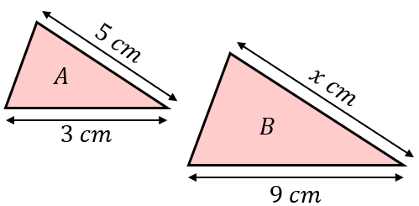 | The two rectangles shown are similar. Find the missing length $x$.  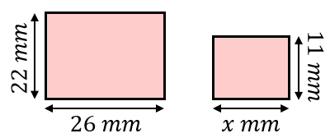 | Shapes $A$ and $B$ are similar. Find the length $x$.  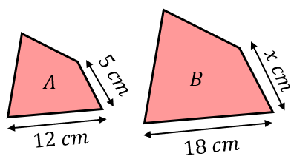
(d) | (e) | (f)
The two triangles shown are similar. Find the missing length $y$.  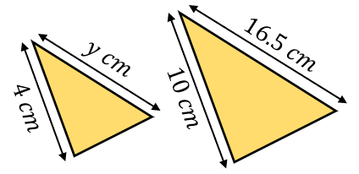 | The two shapes shown are similar. Find the length $x$.  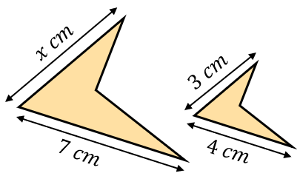 | Find the missing length $y$ cm.  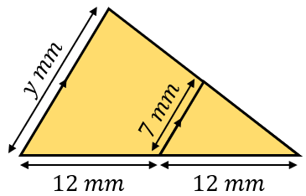
(g) | (h) | (i)
Find the missing length $x$.  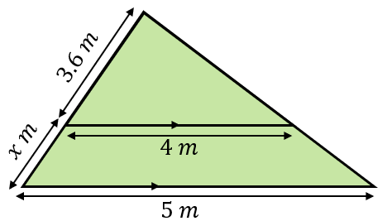 | Find the missing length $x$ in cm.  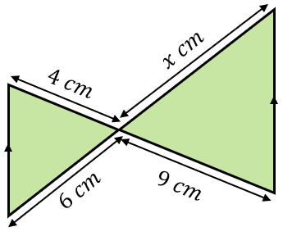 | Find the missing length $y$.  