Using Algebra in Angles
(a) | (b) | (c) | (d)
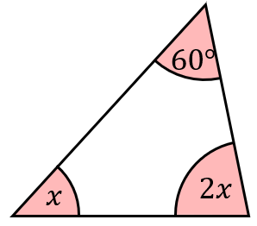  Find the value of $x$. | Find the value of $x$.  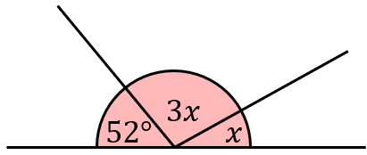 | Find the value of $x$.  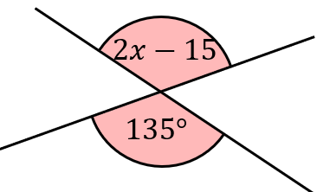 | Find the value of $x$.  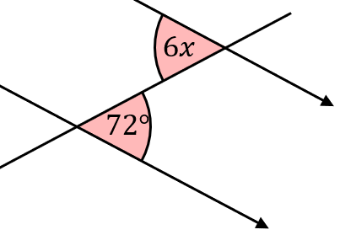
(e) | (f) | (g) | (h)
Find the value of $x$.  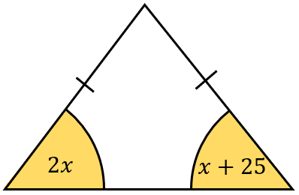 | Find the value of $x$.  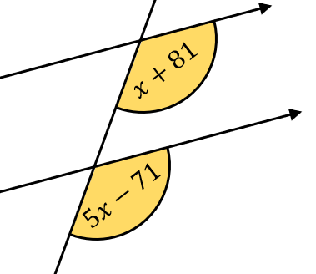 | Find the value of $x$.  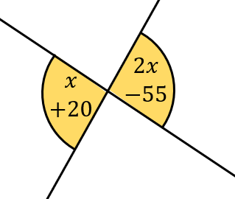 | Find the value of $x$.  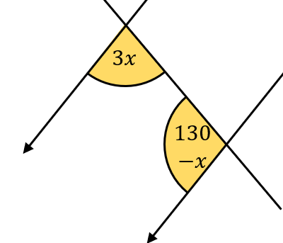
(i) | (j) | (k)
The diagram shows a parallelogram.  Find the value of $x$.  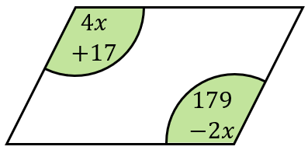 | Find the value of $x$.  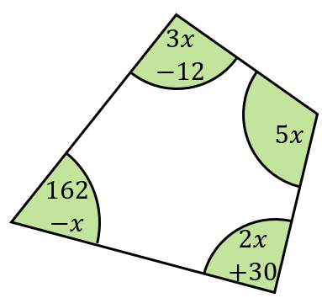 | Show that the lines AB and CD are parallel.  