Reading Cumulative Frequency Graphs
(a) | (b) | (c)
The cumulative frequency graph shows the height of 40 plants in $cm$.  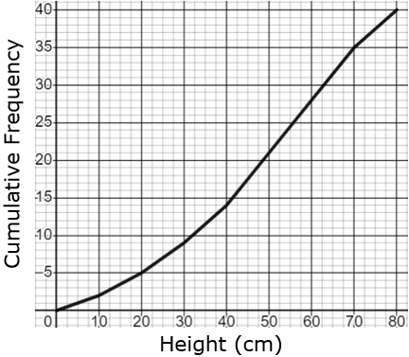  (a) Find the median height of the plants.  (b) Find the interquartile range of the heights of the plants.  (c) Find the number of plants whose height is less than $30 cm$. | The cumulative frequency graph shows the speed of 60 cars in $km/h$.  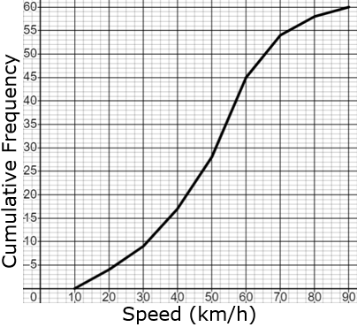  (a) Find the interquartile range of the speeds.  (b) Find the number of cars travelling less than $45 km/h$.  (c) The speed limit is $70 km/h$. What fraction of cars are breaking the speed limit? | The cumulative frequency graph shows the age of 80 apple trees in years.  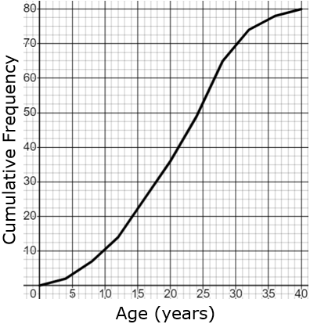  (a) Find the number of trees that are at least 25 years old.  (b) Oscar says “30% of apple trees are less than 15 years old”. Is Oscar correct? You must show working.

