Statistics and Probability Revision |  |  |  | 5
(a) |  | (b)
When a drawing pin is thrown, it can land point up or point down. The probability that the drawing pin lands point up is 0.7. Maya throws the drawing pin twice. |  | The table gives information about the birth weights of 80 piglets.  (i) Complete a cumulative frequency graph.
 |  |  | 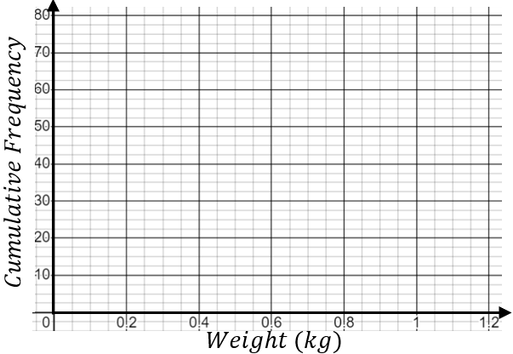
  Weight $w$ (kg) | Cumulative frequency
  $$0≤w<0.2$$ | $$8$$
  $$0.2≤w<0.4$$ | $$17$$
  $$0.4≤w<0.6$$ | $$33$$
  $$0.6≤w<0.8$$ | $$58$$
  $$0.8≤w<1$$ | $$74$$
  $$1≤w<1.2$$ | $$80$$
(i) Complete the tree diagram.  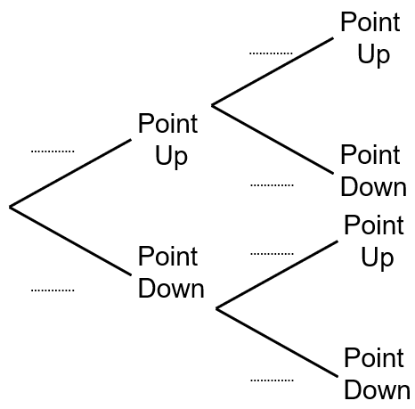 | (ii) Work out the probability that the drawing pin lands point up both times.  (iii) Work out the probability that the drawing pin lands point up exactly once.
 |  | (ii) Use the graph to estimate the median and interquartile range of the weights of the piglets.
(c) |  | (d)
Here is a list of ages of the fifteen students in a school library on a Monday lunchtime.  $$12 9 15 16 10 9 11 10 9 13 15 10 8 17 15$$  (i) Find the median age.  (ii) Find the interquartile range of the ages. |  | Complete the histogram for the information in the table.
 |  |  | 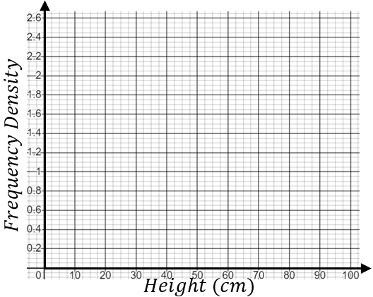
  Height $h$(cm) | Frequency
  $$10≤h<30$$ | $$8$$
  $$30≤h<40$$ | $$18$$
  $$40≤h<50$$ | $$24$$
  $$50≤h<60$$ | $$20$$
  $$60≤h<100$$ | $$12$$

