Algebra Revision |  |  |  | 4
(a) | (b) | (c) | (d)
Factorise fully  $$20b^{3}cd^{2}-16bc^{2}d^{4}$$ | Find the midpoint of the line segment joining $(-1, 8)$ and $(2, -2)$ | Expand and simplify  $$2x(x+4)(x-5)$$ | Solve $3x+7y=13$  $2x+5y=9.5$
(e) | (f)
Find the equation of the line that is parallel to $y=-2x+6$ and passes through $(0, -5)$ | Factorise $4x^{2}+8x-5$
(g) | (h) | (i) | (j)
Make $x$ the subject of the formula $t=\sqrt{\frac{x+a}{b}}$ | Find the gradient of the line that is perpendicular to the line with equation $y=4x+5$ | Use the graph to find the solutions to the equations  $$x+2y=6$$  $$y=x-1.5$$  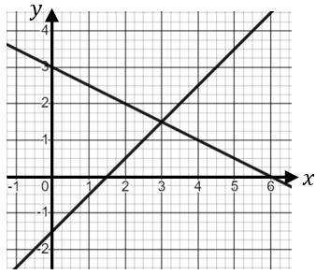 | Shade the region which satisfies the inequalities  $$x+y≤2$$  $$x≥-1$$  $$y≥x-3$$  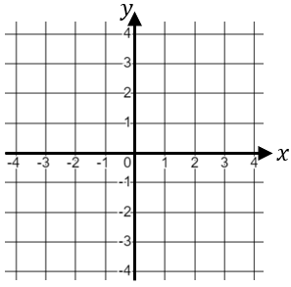
(k) | (l)
$$f\left(x\right)=2x^{2}+x-1$$  Evaluate $f(-3)$ | Solve $2x^{2}-x-6=0$

