Vector Proof – Equating Coefficients
(a) | (b) | (c)
$OABC$ is a quadrilateral, where $\vec{OC}=3a, \vec{OA}=a+2b$ and $\vec{AB}=2a-\frac{1}{2}b$. The point $D$ is on $OB$ and $AC$ such that  $OD : OB=λ: 1$ and $AD : AC=μ: 1.$  By finding two ways to express the vector $\vec{OD}$, find the values of $λ$ and $μ$.  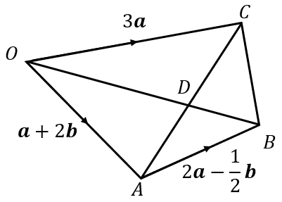 | $OABC$ is a trapezium, where $\vec{OC}=10a, \vec{OA}=a-4b$ and $\vec{AB}=5a$. $M$ is the midpoint of the line $BC$. The point $X$ is on $OB$ and $AM$ such that  $OX : OB=λ: 1$ and $AX : AM=μ: 1.$  Find the values of $λ$ and $μ$and the vector $\vec{OX}$ in terms of $a$ and $b$.  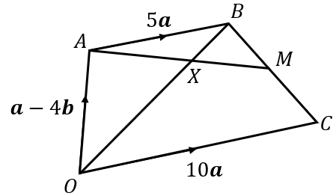 | In the triangle $OAB,$ $\vec{OB}=5b$ and $\vec{OM}=2a+2b,$ where $M$ is the midpoint of $OB$. $OC$ is the line OB produced and $\vec{OB}=\vec{BC}$. The point $X$ is on the line $AB$ such that $AX :AB=λ :1$. Given that $MXC$ is a straight line, find the value of $λ$ and the vector $\vec{MX}$ in terms of $a$ and $b$.  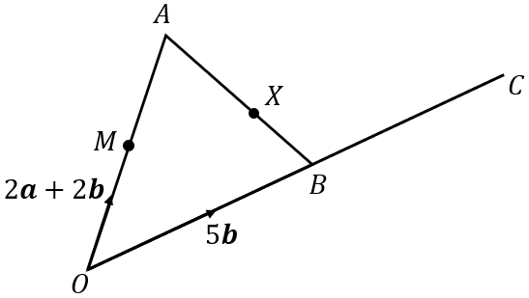
and

