Geometry Revision |  |  |  | 2
(a) | (b) | (c) | (d)
(i) Write down the order of rotational symmetry of the shape  shown.  (ii) Draw all the lines of symmetry on the shape below. | Work out the volume of this cuboid. Give units with your answer.  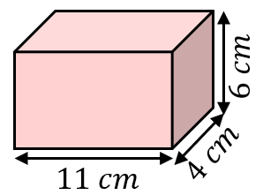 | Calculate the perimeter of the shape shown. Give units with your answer.  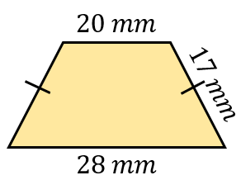 | The map shown has a scale $1 cm :60 km$. Find the actual distance between Martown and Pencaster.  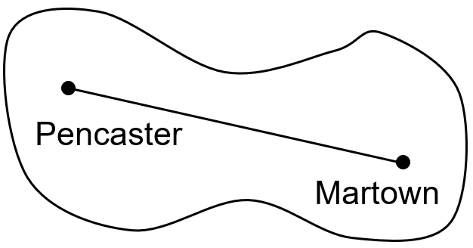
(e) | (f) | (g) | (h)
Using ruler and compasses only, construct the perpendicular bisector of the line given. | Work out the area of the shape shown. Give units with your answer.  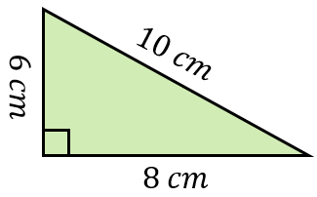 | Work out the value of $x$. Give reasons for your answer.  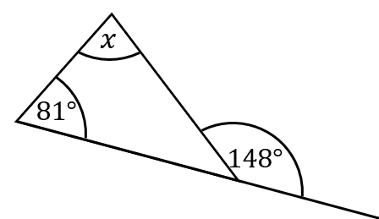 | Using ruler and compasses only, construct the bisector of the angle below.

