Order of Operations
(a) | (b) | (c) | (d)
Calculate  $$13+5×2$$ | Calculate  $$30-15÷5$$ | Calculate  $$2+7-4×3$$ | Calculate  $$24-4×2+9$$
(e) | (f) | (g) | (h)
Calculate  $$6+4^{2}-5$$ | Calculate  $$(4+{3)}^{2}-5×2$$ | Calculate  $$100-2×3^{3}$$ | Calculate  $${2×6}^{2}-3×\sqrt{25}$$
(i) | (j) | (k) | (l)
Calculate  $$-3+10+7×-4$$ | Calculate  $$\sqrt{40-4×{(-1)}^{2}}$$ | Calculate  $$\frac{0.5×4^{2}}{7-3}$$ | Calculate  $$\frac{7.5-2×{1.5}^{2}}{\sqrt{8-2^{2}}}$$
(m) | (n) | (o) | (p)
Add brackets to make the calculation correct.  $$5+6-2^{ 2}×3=53$$ | Add brackets to make the calculation correct.  $$\frac{8×{0.5}^{ 2}-(-8)}{-5+2×-1}=8$$ | Insert the numbers 1, 4, 5 and 8 once each to make the biggest number possible.  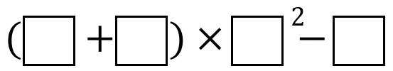 | Insert the numbers 2, 3, 5 and 10 once each to make the smallest number possible.  