Geometry Revision |  |  |  | 4
(a) | (b) | (c) | (d)
Find the length of $y$, giving your answer to 1 decimal place.  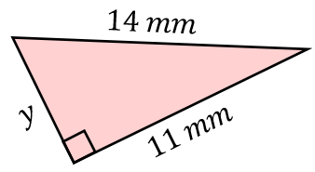 | On the grid, rotate triangle A $90°$ clockwise about the point $(-1, -1)$  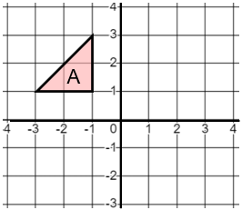 | A train travels at a speed of $216 km/h$. The train travels from London to Paris in $2$ hours $18$ minutes. Find the distance travelled. | Find the value of angle $x$, giving your answer to 1 decimal place.  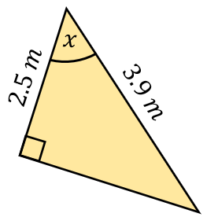
(e) | (f) | (g) | (h)
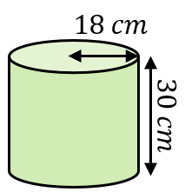  The cylinder shown is completely filled with water. Find the volume of water in the cylinder, giving your answer in litres to 3 significant figures. | Find the value of $x$, giving your answer to 1 decimal place.  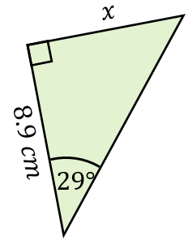 | The bearing of B from A is $079°$. Calculate the bearing of A from B.  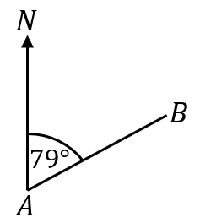 | Find the area and perimeter of the sector shown. Give your answers to 3 significant figures.  