3D Pythagoras and Trigonometry
(a) | (b)
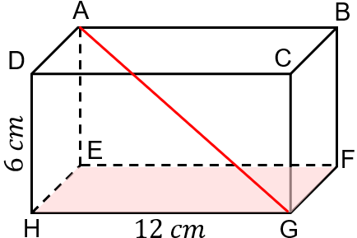  The volume of the cuboid ABCDEFGH is $360 {cm}^{3}$. Find:  (a) the length of AD  (b) the length of AG  (c) the angle between AG and the plane EFGH | The point J splits the edge EF in the ratio $2 : 1$. Find:  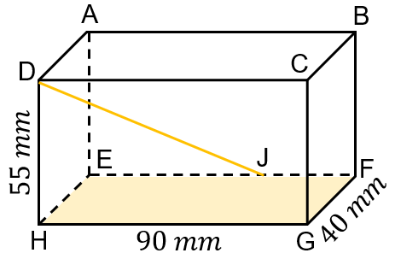  (a) the length HJ  (b) the length DJ  (c) the angle HDJ  (d) The angle between DJ and the plane EFGH
(c) | (d)
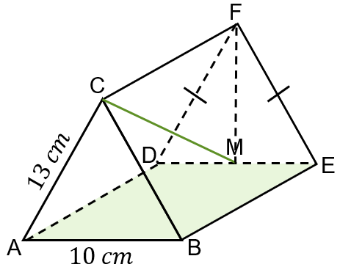  ABCDEF is a triangular prism with a surface area of $660 {cm}^{2}.$ M is the midpoint of DE. Find:  (a) the length of MF  (b) the length of BE  (c) the length of CM  (d) the angle between CM and the plane ABED | The volume of the square-based pyramid ABCDE is $180 {cm}^{3}$. M is the centre of the base and is vertically below E. Find:  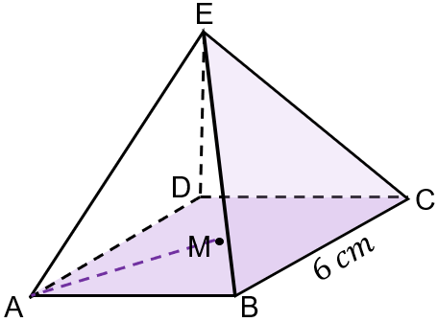  (a) the height of the pyramid ME  (b) the length of AE  (c) the angle EAM  (d) the angle between the planes BCE and ABCD

