Algebraic Problems involving Area of Non Right-Angled Triangles
(a) | (b) | (c)
Given the area is $21 {cm}^{2}$, find the value of $x$  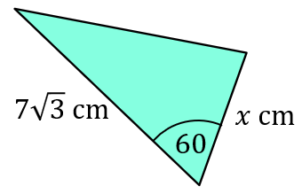 | Given the area is $7.5 {cm}^{2}$, find the value of $x$  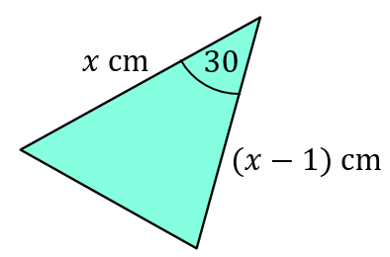 | Given the area is $8 {cm}^{2}$, find the value of $x$  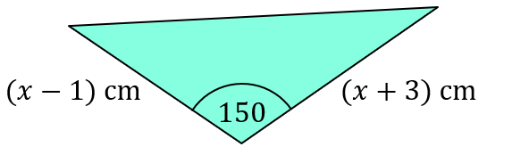
(d) | (e) | (f)
Find the exact area of the triangle.  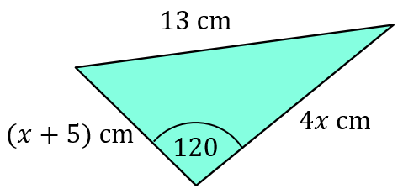 | Find the exact area of the triangle.  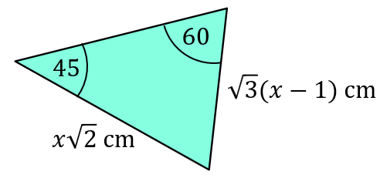 | Find the exact area of the quadrilateral.  