Congruent Triangle Proof
(a) | (b)
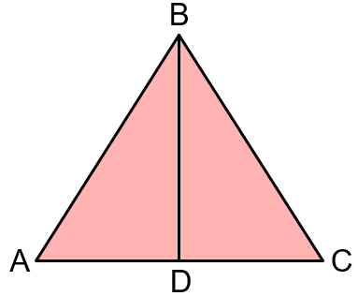  The diagram shows an equilateral triangle. BD is perpendicular to AC. Prove that triangles ABD and CBD are congruent. | 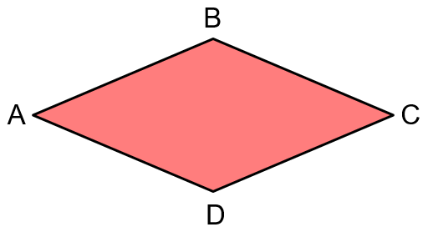  The diagram shows a rhombus ABCD. Prove that triangles ABC and ADC are congruent.
(c) | (d)
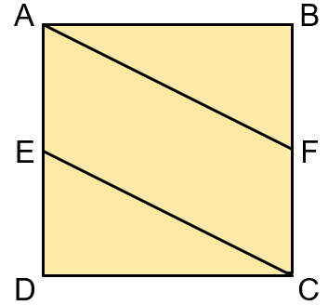  ABCD is a square. E is the midpoint of AD and F is the midpoint of BC. Prove that triangles ABF and CDE are congruent. | 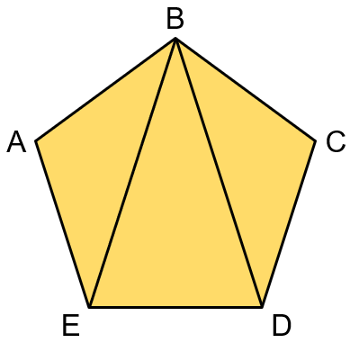  ABCDE is a regular pentagon. Prove that triangles ABE and CBD are congruent.
(e) | (f)
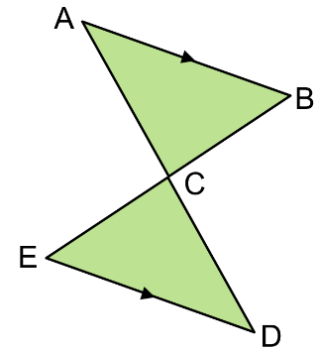  In the diagram, AB and DE are parallel, and C is the midpoint of BE. Prove that triangles ABC and CDE are congruent. | 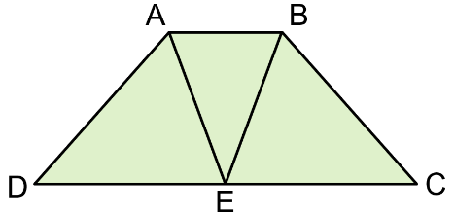  ABCD is a trapezium. ABE is an isosceles triangle where AE = BE, and E is the midpoint of CD. Prove that triangles ADE and BCE are congruent.

