Fill In The Blanks…
Evaluating Three-Step Functions

Question | Input | Function Machine |  |  | Output
$$f\left(x\right)=({2x+1)}^{2}$$  Find $f(4)$ | 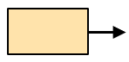 | 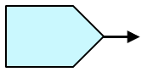 |  | 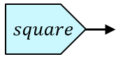
$$g\left(x\right)=\frac{2x-5}{3}$$
Find $g(6.25)$
$$f\left(x\right)=\sqrt{3x-2}$$  Find $f(9)$ |  |  |  | 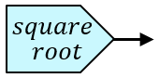
$$h\left(x\right)=2(x^{3}-6)$$
Find $h(-2)$
$$f\left(x\right)=\frac{3}{x}+7.5$$  Find $f(2)$ |  | 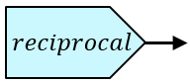
$f\left(x\right)=$  Find | 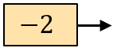 | 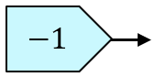 |  | 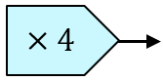
$f\left(x\right)=$  Find | 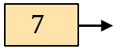 | 