🅒🅡🅐🅒🅚 🅣🅗🅔 🅒🅞🅓🅔 |  | 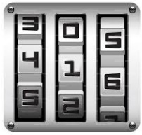
Round 143 to the nearest 100 | Round 46 to the nearest 10
Round 27.9 to the nearest 10 | Round 18.9 to the nearest whole number
Round 184.35 to the nearest whole number | Round 84.99 to the nearest whole number
Round 4.876 to 1 decimal place | Round 13.375 to 1 decimal place
Round 13.578 to 2 decimal places | Round 72.153 to 2 decimal places
Round 56 to 1 significant figure | Round 212 to 1 significant figure
Round 18.9 to 1 significant figure | Round 7.89 to 1 significant figure
Round 0.597 to 1 significant figure | Round 0.0412 to 1 significant figure
Round 85.66 to 2 significant figures | Round 23.64 to 2 significant figures
Round 1.529 to 2 significant figures | Round 0.8264 to 2 significant figures
Add together all your answers and round to the nearest integer to get the three-digit code.

