Volume and Surface Area Revision
(a) | (b) | (c) |  | (d)
The volume of a cuboid is $320 {cm}^{3}.$ Its height is $16 cm$ and the length is $5 cm$. Find the width of the cuboid. | Find the surface area of a cube with side length $8.5 cm$. | The volume of the prism is $264 {cm}^{3}.$Find $x$.  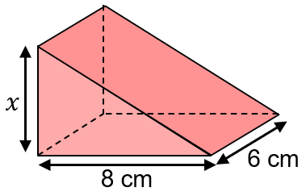 |  | Find the surface area of this prism.  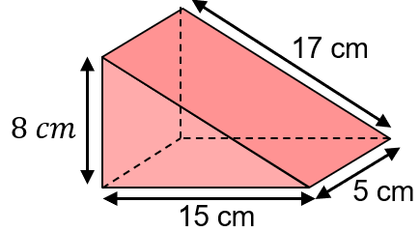
(e) | (f) | (g) |  | (h)
Find the volume of the cylinder, giving your answer to 3 significant figures.  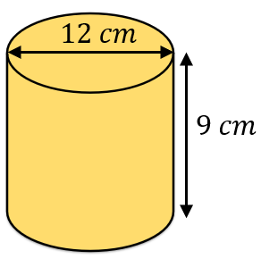 | Find the total surface area of the cylinder, leaving your answer in terms of $π.$  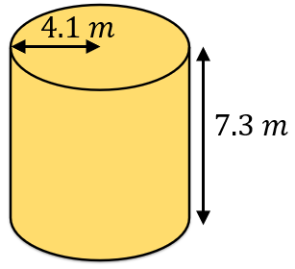 | The volume of a sphere is $288π {cm}^{3}$. Find the radius of the sphere. |  | Find the total surface area of the hemisphere, giving your answer to 3 significant figures.  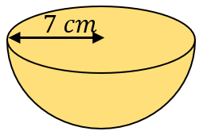
(i) | (j) |  | (k)
Find the volume of the cone, leaving your answer in terms  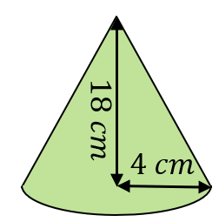  of $π.$ | 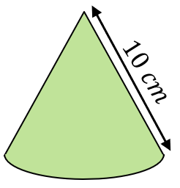  A cone has a slanted height of $10 cm$ and a curved surface area of $60π {cm}^{2}.$ Find the volume of the cone, giving your answer to 3 significant figures. |  | A cylinder has a height of $16 cm$ and a radius of $x cm$. A sphere has a radius of $2x cm$. The volume of the cylinder and the sphere are equal. Find the value of $x$.

