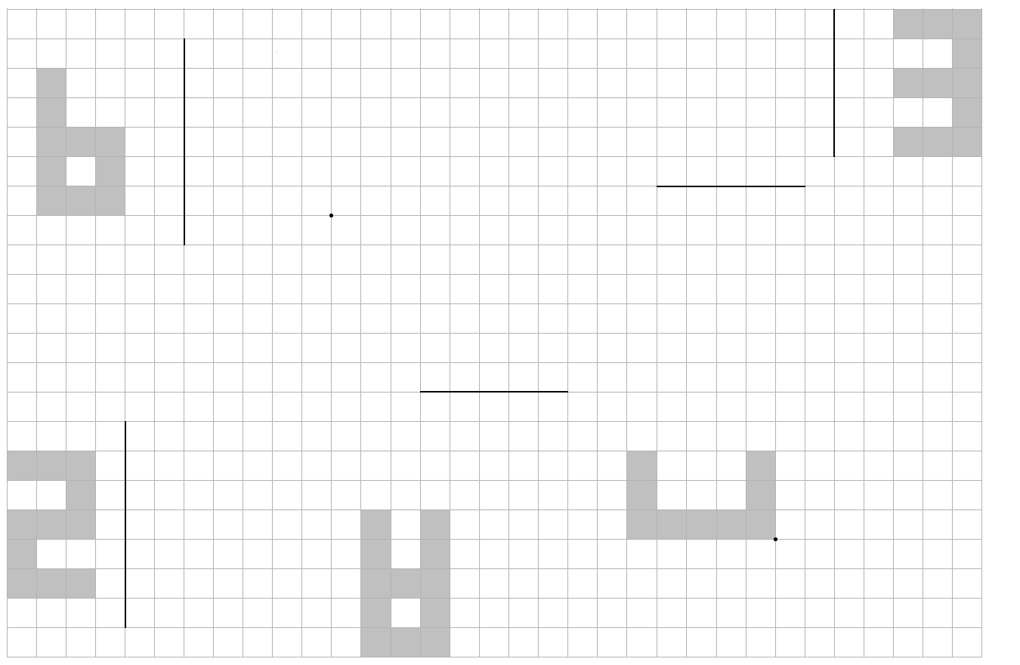

Reflect in line F then reflect in line G

Rotate 90o clockwise about E then translate by

Translate by

then reflect in line D

Reflect in line A

then translate

by

Reflect in line B then rotate 180o about C

**F**

**G**

**E**

**D**

**A**

**C**

**B**