Representing Inequalities
(a) | (b) | (c) | (d) | (e)
Write down the inequality shown.  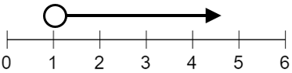 | Write down the inequality shown.  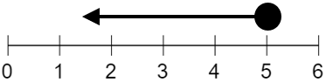 | Write down the inequality shown.  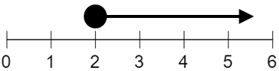 | Write down the inequality shown.  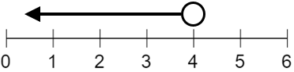 | Write down the inequality shown.  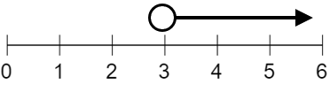
(f) | (g) | (h) | (i) | (j)
Write down the inequality shown.  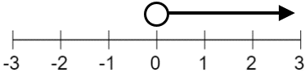 | Write down the inequality shown.  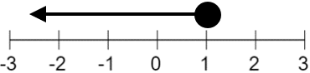 | Write down the inequality shown.  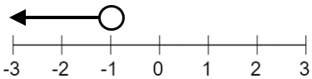 | Write down the inequality shown.  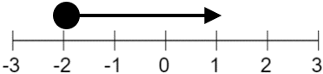 | Write down the inequality shown.  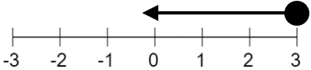
(k) | (l) | (m) | (n) | (o)
Show the inequality  $$x>3$$  on the number line.  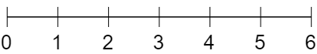 | Show the inequality  $$x≤4$$  on the number line. | Show the inequality  $$x≥2$$  on the number line. | Show the inequality  $$x>0$$  on the number line. | Show the inequality  $$x<5$$  on the number line.
(p) | (q) | (r) | (s) | (t)
Show the inequality  $$x≤1$$  on the number line.  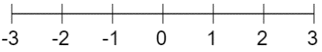 | Show the inequality  $$x>-2$$  on the number line. | Show the inequality  $$x<-1$$  on the number line. | Show the inequality  $$x≥-3$$  on the number line. | Show the inequality  $$x≤0$$  on the number line.

