Fill In The Blanks…
Dividing Fractions

Division | Equivalent Multiplication | Unsimplified Answer | Simplified Answer (where possible)
$$\frac{2}{3}÷6$$ | $$\frac{2}{3}×\frac{1}{6}$$ | $$\frac{2}{18}$$
$$\frac{2}{5}÷4$$ | $$\frac{2}{5}×\frac{1}{4}$$
$$\frac{5}{8}÷10$$ | 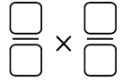
$$\frac{7}{10}÷\frac{3}{4}$$ | $$\frac{7}{10}×\frac{4}{3}$$
$$\frac{6}{11}÷\frac{2}{3}$$
$$\frac{1}{10}÷\frac{4}{5}$$
$$\frac{11}{16}÷\frac{3}{4}$$
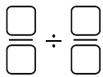 | $$\frac{2}{9}×\frac{6}{5}$$
 | $$\frac{3}{8}×$$ | $$\frac{12}{24}$$
$$÷\frac{2}{5}$$ |  | $$\frac{15}{20}$$
 | $$\frac{5}{12}×$$ | $$\frac{10}{12}$$
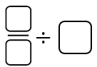 | $$×\frac{1}{3}$$ |  | $$\frac{3}{10}$$

