Shading Two Set Venn Diagrams
(a) | (b) | (c) | (d)
Shade $A'$  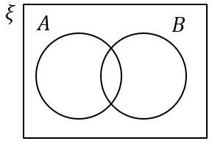 | Shade $A∩B$ | Shade $A∪B$ | Describe the region shaded  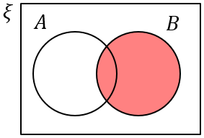
(e) | (f) | (g) | (h)
Describe the region shaded  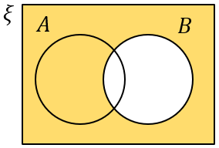 | Shade $A∩B'$ | Shade $A'∩B'$ | Describe the region shaded  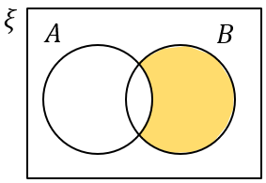
(i) | (j) | (k) | (l)
Shade $A'∪B$ | Shade $(A∪B)'$ | Describe the region shaded  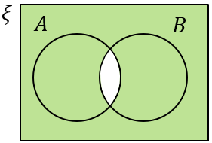 | Describe the region shaded  