Finding Frequencies from Cumulative Frequency Graphs
(a)
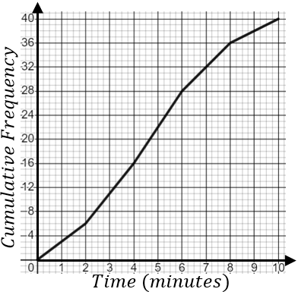 | Complete the cumulative frequency table.  Time (minutes) Cumulative Frequency  $$0<t≤2$$ 6  $$0<t≤4$$ 16  $$0<t≤6$$  $$0<t≤8$$  $$0<t≤10$$ 40 | Complete the grouped frequency table.  Time (minutes) Frequency  $$0<t≤2$$ 6  $$2<t≤4$$ 10  $$4<t≤6$$  $$6<t≤8$$  $$8<t≤10$$
(b)
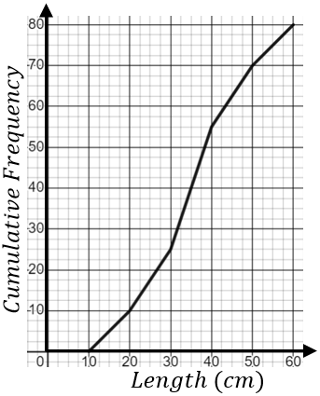 | Complete the cumulative frequency table.  Length (cm) Cumulative Frequency  $$0<l≤10$$ 0  $$0<l≤20$$ 10  $$0<l≤30$$  $$0<l≤40$$  $$0<l≤50$$  $$0<l≤60$$ |  | Complete the grouped frequency table.  Length (cm) Frequency  $$0<l≤10$$  $$10<l≤20$$  $$20<l≤30$$  $$30<l≤40$$  $$40<l≤50$$  $$50<l≤60$$
(c)
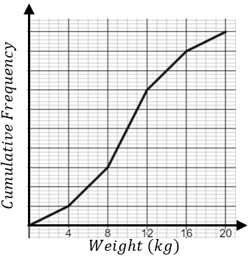 | Complete the cumulative frequency table.  Weight (kg) Cumulative Frequency  $$0<w≤4$$  $$0<w≤8$$  $$0<w≤12$$  $$0<w≤16$$  $$0<w≤20$$ |  | Complete the grouped frequency table.  Weight (kg) Frequency  $$0<w≤4$$  $$4<w≤8$$ 10  $$8<w≤12$$  $$12<w≤16$$  $$16<w≤20$$

