Constructing an Equilateral Triangle
For this construction you will need to work on a piece of A4 paper in portrait.
Step 1 – Draw a horizontal line halfway down your paper. Measure an 8 cm line and mark each end of the line in pencil. | Step 2 – Open your compasses to 8cm, put the compass point on the right-hand mark and draw an arc above the line.  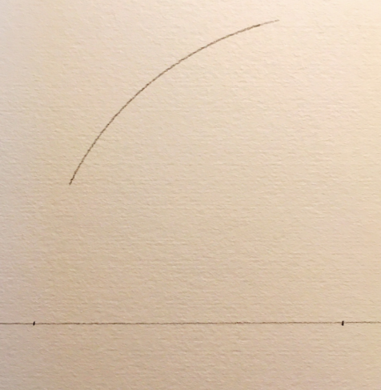 | Step 3 – Keeping compasses at same radius, put the compass point on the left-hand marks and draw another arc.  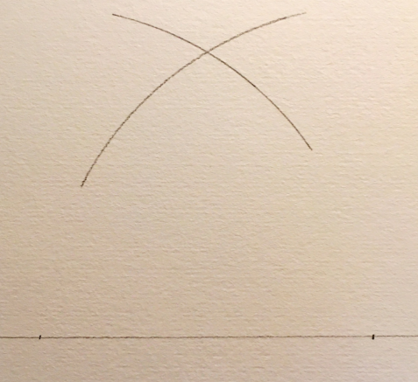
Step 4 – Using a ruler, join the point where the arcs cross to either end of the 8 cm horizontal line.  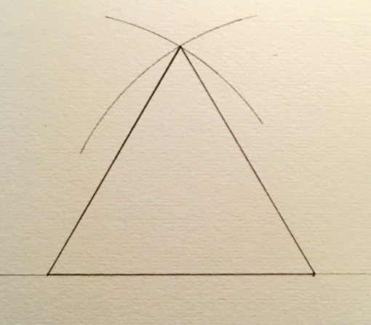 | Step 5 – Use pencil crayons or fineliners to colour your equilateral triangle!  