Fill In The Blanks…
Solving Quadratic Inequalities

Quadratic Inequality | Factorised Quadratic | Critical Values | Sketch and Shade | Solution
$$x^{2}-3x-10<0$$ | $$\left(x-5\right)\left(x+2\right)<0$$ | $$x=5,$$  $$x=-2$$ | 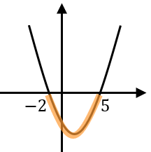 | $$-2<x<5$$
$$x^{2}+4x-12<0$$ | $$\left(x+6\right)\left(x-2\right)<0$$
$$x^{2}-6x+5<0$$
$$x^{2}+5x+6≤0$$
$$x^{2}-4x-12>0$$ | $$\left(x-6\right)\left(x+2\right)>0$$ | $$x=6,$$  $$x=-2$$ | 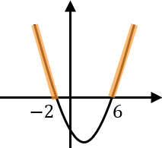 | $$x<-2,$$  $$x>6$$
$$x^{2}+4x+3≥0$$
$$x^{2}-x-6≥0$$
 |  |  |  | $$-4<x<1$$

