Conversion Graphs
(a) | (b)
(i) Complete the table to convert miles to kilometres, then draw a conversion graph.  Miles $$10$$ $$20$$ $$30$$ $$40$$ $$50$$  Kilometres $$16$$ $$64$$  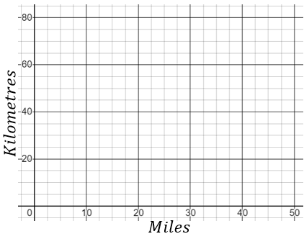  (ii) Use the graph to convert 55 km into miles. | 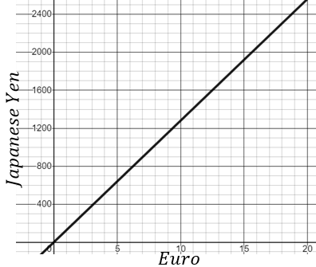  The graph shown converts euros to Japanese yen.  (a) Convert 10 euros to Japanese yen.  (b) Convert 400 Japanese yen into euros.
(c) | (d)
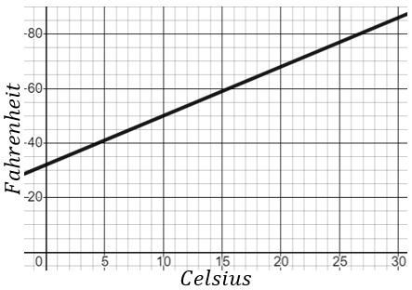  The graph shown converts temperatures from Fahrenheit ($℉$) to Celsius ($℃$).  (a) Convert $10℃$ into $℉$.  (b) The temperature of a room increases by $20℉$. What is the equivalent increase in $℃$? | The graph shown converts Euros to US dollars.  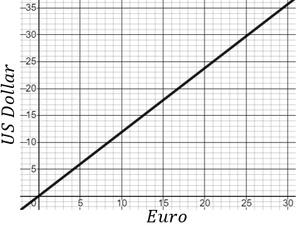  Given that $1 Euro = 10.2 Swedish krona$,  convert 250 US dollars into Swedish krona.

