Constructing a Square
For this construction you will need to work on a piece of A4 paper in portrait.
Step 1 – Draw a horizontal line halfway down your paper. Mark a point halfway along the line. | Step 2 – Draw a circle of radius 6 cm | Step 3 – Construct the perpendicular bisector of the horizontal line joining the left and right edges of the circle.  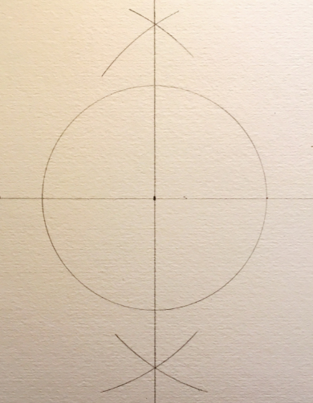
Step 4 – Reset your compasses to 6 cm, place the compass point at the right intersection point and draw slightly more than a semi-circle. Repeat at the left side.  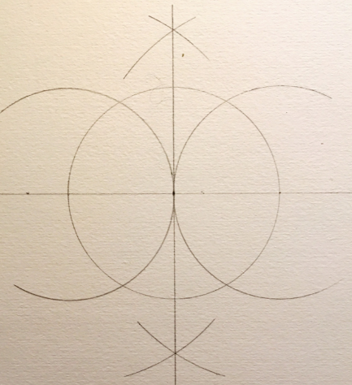 | Step 5 – Repeat step 4 from the top and bottom points where the circle intersects with the perpendicular bisector.  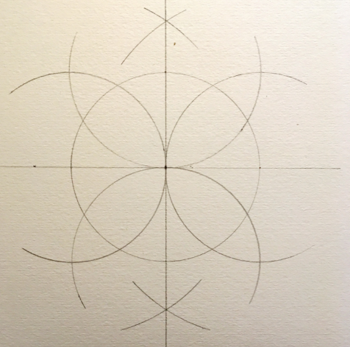 | 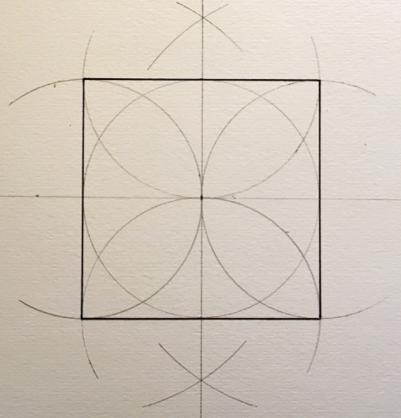  Step 6 – Using a ruler, join the four points where the semi-circles intersect.
Step 7 – Colour your square using pencil crayons or fineliners!
