Circle Theorems and Triangles
(a) | (b) | (c)
Find the missing angle $a$.  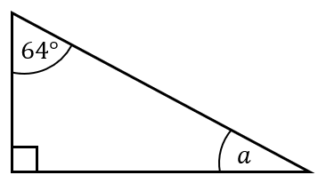 | Find the missing angle $b$.  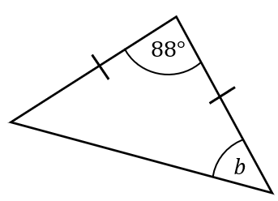 | Find the missing angles $c$ and $d$.  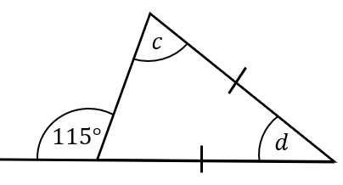
(d) | (e) | (f)
What type of triangle is inside the circle?  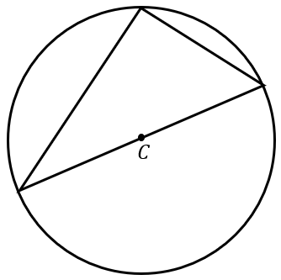 | What type of triangle is inside the circle?  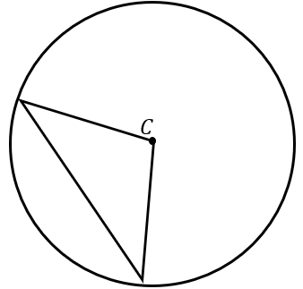 | What type of triangle is inside the circle?  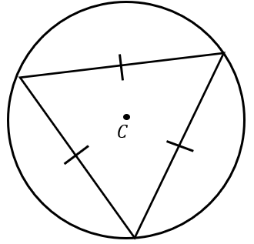
(g) | (h) | (i)
Find the missing angle $y$.  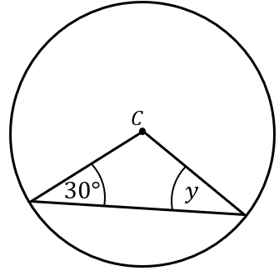 | Find the missing angle $x$.  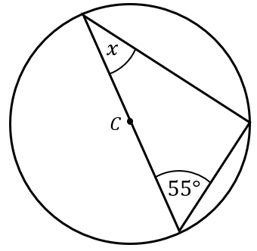 | Find the missing angles $a$ and $b$.  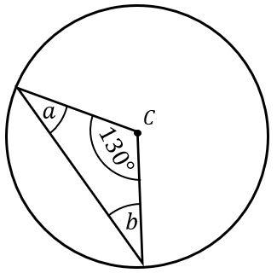
(j) | (k) | (l)
Find the missing angle $y$.  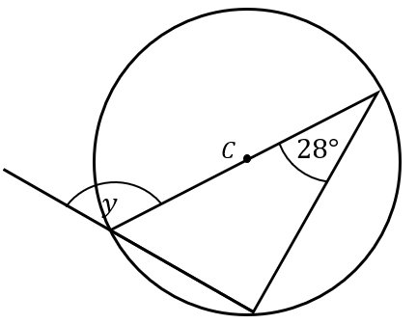 | Find the missing angle $a$.  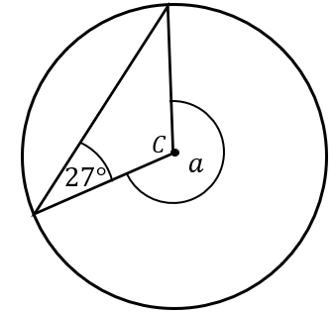 | Find the missing angles $x$ and $y$.  