Prime Factors, HCF and LCM
Write $70$ as a product of its prime factors | Find the highest common factor (HCF) of $15$ and $25$ | Find the lowest common multiple (LCM) of $12$ and $9$ | Use a Venn diagram to find the HCF and LCM of $20$ and $35$
Draw a factor tree:  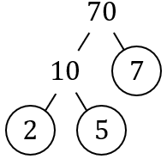  $$70=2×5×7$$ | Factors of $15$: $1, 3, 5, 15$  Factors of $25$ : $1, 5, 25$  HCF is $5$ | Multiples of $12$:  $$12, 24, 36,48,…$$  Multiples of $9$ :  $$9, 18, 27, 36,…$$  LCM is $36$ | $20=2×2×5$ $35=5×7$  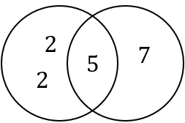  HCF$=5$  LCM $=2×2×5×7=140$
Write $50$ as a product of its prime factors | Find the HCF of $8$ and $20$ | Find the LCM of $5$ and $8$ | Use a Venn diagram to find the HCF and LCM of $25$ and $40$
Write $66$ as a product of its prime factors | Find the HCF of $12$ and $15$ | Find the LCM of $6$ and $9$ | Use a Venn diagram to find the HCF and LCM of $35$ and $42$
Write $108$ as a product of its prime factors | Find the HCF of $16$ and $24$ | Find the LCM of $8$ and $20$ | Use a Venn diagram to find the HCF and LCM of $45$ and $60$

