Vectors and Coordinates
(a) | (c) | (e)
$ABCD$ is a parallelogram.  $\vec{AB}=\left(\begin{matrix}-2 \\ 3\end{matrix}\right)$ and $\vec{AD}=\left(\begin{matrix}3 \\ 5\end{matrix}\right)$  Given that the coordinates of $A$ are $(3, 1)$, find the coordinates of points $B$, $C$and $D$.  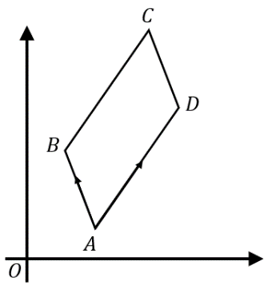 | $ABCD$ is a parallelogram. $\vec{BC}=\left(\begin{matrix}3 \\ 2\end{matrix}\right)$  The coordinates of $A$ are $(2, 7)$ and of $B$ are $(8, 3)$. Find the coordinates of $C$ and $D$, and the vector $\vec{DC}$.  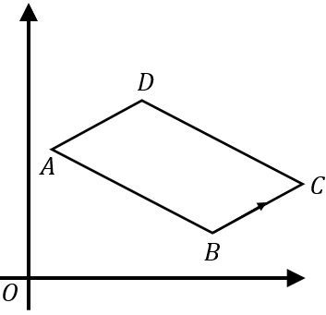 | $ABCD$ is a trapezium. $\vec{AB}=2\vec{DC}$.  $\vec{DC}=\left(\begin{matrix}3 \\ 1\end{matrix}\right)$ and $\vec{BC}=\left(\begin{matrix}-3 \\ 4\end{matrix}\right)$  The coordinates of $D$ are $(2, 8)$. Find the coordinates of $A$, and the vector $\vec{AD}$.  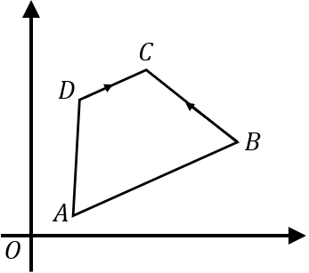
(b) | (d) | (f)
$ABCD$ is a parallelogram.  $\vec{AD}=\left(\begin{matrix}6 \\ 1\end{matrix}\right)$ and $\vec{DC}=\left(\begin{matrix}2 \\ 4\end{matrix}\right)$  Given that the coordinates of $A$ are $(0, 1)$, find the coordinates of points $B$, $C$and $D$.  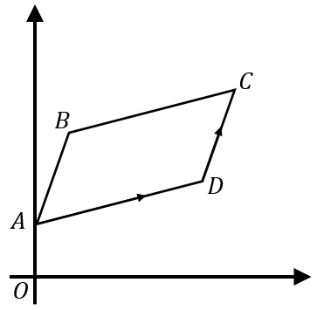 | $ABCD$ is a rhombus. $\vec{CB}=\left(\begin{matrix}-3 \\ -4\end{matrix}\right)$  The coordinates of $A$ are $(-1, 4)$ and of $B$ are $(3, 1)$. Find the coordinates of $C$ and $D$, and the vector $\vec{DC}$.  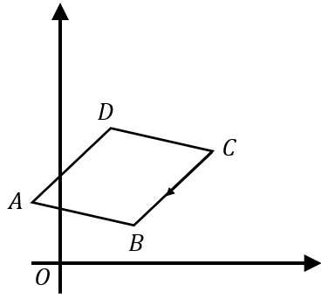 | $ABCDEF$ is a regular hexagon.  $\vec{AB}=\left(\begin{matrix}4 \\ 0\end{matrix}\right)$ and $\vec{FE}=\left(\begin{matrix}2 \\ 2\sqrt{3}\end{matrix}\right)$  $\vec{FC}=2\vec{AB}$. The coordinates of $A$ are $(5, 2)$. Find the coordinates of $B$, $C$ and $D$.  