Circle Problems in Reverse

(a) A circle has a circumference of $50 cm$. Find the diameter of the circle to 1 decimal place.
(b) A circle has a circumference of $24π cm$. Find the diameter of the circle.
(c) A circle has a circumference of $115 mm$. Find the radius of the circle to 1 decimal place.

(a) A circle has an area of $16π {cm}^{2}$. Find the radius of the circle.
(b) A circle has an area of $82 {cm}^{2}$. Find the radius of the circle to 1 decimal place.
(c) A circle has an area of $14.2 m^{2}$. Find the diameter of the circle correct to 1 decimal place.

(a) A semi-circle has an area of $35 {cm}^{2}$. Find the radius of the semi-circle to 1 decimal place.
(b) A semi-circle has an area of $32π {cm}^{2}$. Find the diameter of the semi-circle.
(c) A quarter circle has an area of $4 m^{2}$. Find the radius of the quarter circle to 1 decimal place.

Given the total area of this compound shape is $100 cm^{2}$ and the area of the rectangle is $66 cm^{2}$, find length and width of the rectangle.
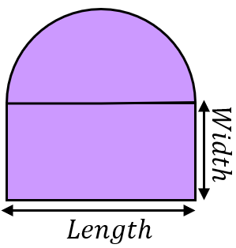
Circle Problems in Reverse

(a) A circle has a circumference of $50 cm$. Find the diameter of the circle to 1 decimal place.
(b) A circle has a circumference of $24π cm$. Find the diameter of the circle.
(c) A circle has a circumference of $115 mm$. Find the radius of the circle to 1 decimal place.

(a) A circle has an area of $16π {cm}^{2}$. Find the radius of the circle.
(b) A circle has an area of $82 {cm}^{2}$. Find the radius of the circle to 1 decimal place.
(c) A circle has an area of $14.2 m^{2}$. Find the diameter of the circle correct to 1 decimal place.

(a) A semi-circle has an area of $35 {cm}^{2}$. Find the radius of the semi-circle to 1 decimal place.
(b) A semi-circle has an area of $32π {cm}^{2}$. Find the diameter of the semi-circle.
(c) A quarter circle has an area of $4 m^{2}$. Find the radius of the quarter circle to 1 decimal place.

Given the total area of this compound shape is $100 cm^{2}$ and the area of the rectangle is $66 cm^{2}$, find length and width of the rectangle.

