Solving Geometric Problems with Simultaneous Equations
(a) The square and the triangle both have a perimeter of $40 cm$. Find the values of $x$ and $y$.
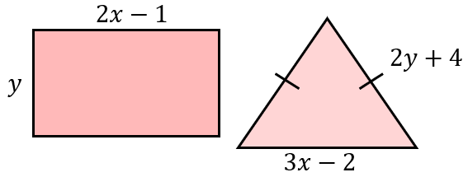

(b) Work out the values of $x$ and $y$.
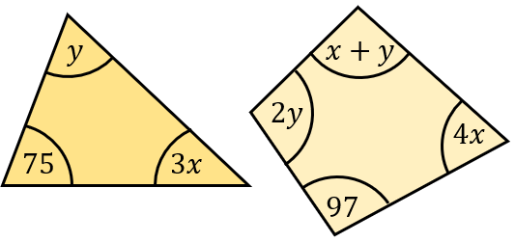

(c) Here is a rectangle. By first finding the value of $a$ and the value of $b$, find the area of the rectangle.
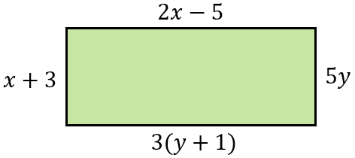

(d) These shapes are made of congruent rectangles of length $x$ and width $y$ where $x>y$. Find the values of $x$ and $y$ for each of the diagrams.
(i) (ii)
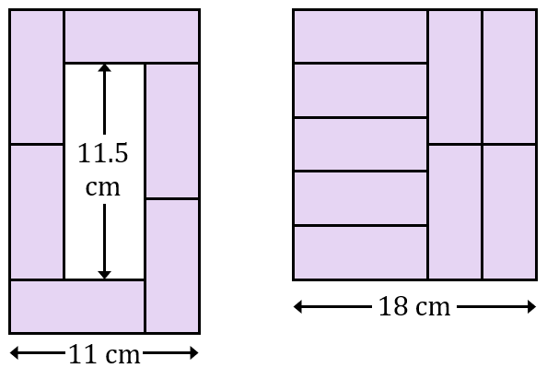
Solving Geometric Problems with Simultaneous Equations
(a) The square and the triangle both have a perimeter of $40 cm$. Find the values of $x$ and $y$.

(b) Work out the values of $x$ and $y$.

(c) Here is a rectangle. By first finding the value of $a$ and the value of $b$, find the area of the rectangle.

(d) These shapes are made of congruent rectangles of length $x$ and width $y$ where $x>y$. Find the values of $x$ and $y$ for each of the diagrams.
(i) (ii)

