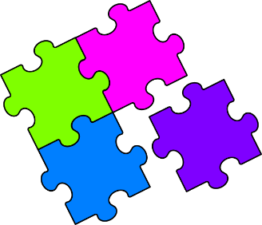
Match-Up
Harder Indices

1 | $$\sqrt[3]{2}$$ |  | 6 | $${\left(\frac{1}{\sqrt[3]{2}}\right)}^{4}$$ |  | 11 | $${\left(\sqrt[3]{2^{2}}\right)}^{2}$$
2 | $$\frac{1}{2}$$ |  | 7 | $$\sqrt{2^{3}×2^{6}}$$ |  | 12 | $$\sqrt[4]{2}×{\left(\sqrt{2}\right)}^{3}$$
3 | $$\frac{1}{\sqrt{2}}$$ |  | 8 | $$\frac{1}{2^{2}×\sqrt{2}}$$ |  | 13 | $$\frac{1}{2\sqrt{2}}×\frac{1}{2^{3}}$$
4 | $$\sqrt{2^{3}}$$ |  | 9 | $${\sqrt{2}}^{3}×2^{2}$$ |  | 14 | $$\frac{{\left(2^{3}\right)}^{2}×\sqrt[3]{2^{4}}}{{\left(\sqrt[3]{2}\right)}^{8}}$$
5 | $$\frac{1}{\sqrt[3]{2^{2}}}$$ |  | 10 | $$\frac{\sqrt{2}}{\sqrt[4]{2}}$$ |  | 15 | $$\sqrt{\frac{2}{\sqrt[3]{2}×2^{3}}}$$
A | $$2^{-4/3}$$ |  | F | $$2^{-5/2}$$ |  | K | $$2^{-2/3}$$
B | $$2^{7/4}$$ |  | G | $$2^{-1/2}$$ |  | L | $$2^{1/4}$$
C | $$2^{3/2}$$ |  | H | $$2^{-7/6}$$ |  | M | $$2^{1/3}$$
D | $$2^{{14}/3}$$ |  | I | $$2^{4/3}$$ |  | N | $$2^{-9/2}$$
E | $$2^{-1}$$ |  | J | $$2^{9/2}$$ |  | P | $$2^{7/2}$$

1 | 2 | 3 | 4 | 5 | 6 | 7 | 8 | 9 | 10 | 11 | 12 | 13 | 14 | 15

