Constructing Bar Charts
(a) |  | (b)
The table shows the number of different coloured cars recorded one day. Complete the bar chart to represent the data.  Colour Frequency  Red $$16$$  Blue $$2$$  White $$9$$  Black $$14$$ | 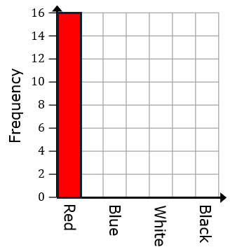 | The table shows the number of students receiving merits on each day of a week. Draw a bar chart to represent the data.  Day Frequency  Monday $$14$$  Tuesday $$7$$  Wednesday $$10$$  Thursday $$0$$  Friday $$9$$ | 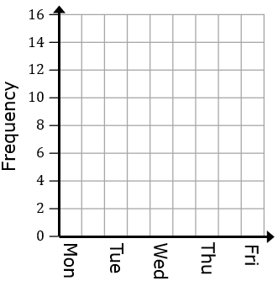
(c) |  | (d)
$40$ children were surveyed about their favourite subject at school. Complete the table and draw a bar chart.  Subject Frequency  Maths $$9$$  English $$6$$  Science $$11$$  History  PE $$4$$ | 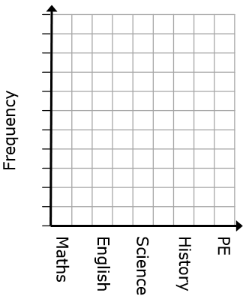 | The table shows the number of books read by students in a month. They read $50$ books in total. Ava read twice as many books as Dinah. Complete the table and draw a bar chart.  Student Frequency  Ava  Bola $$20$$  Cerys $$9$$  Dinah |  | 