Harder Two Set Practical Problems

There are 30 students in a class. 18 study Spanish. 13 study German. 7 study neither Spanish nor German. Complete the Venn diagram to represent this information and find the number of students who study Spanish and German.
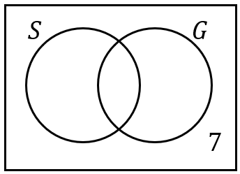

In a group of 25 people, 8 said they had been to the theatre recently. 15 said they had been to the library recently, and 10 said they had been to neither the theatre or the library recently. Draw a Venn diagram to represent this information and find the number of people who had only been to the library recently.

In a class of 30 students, 15 play football and 11 play tennis. Twice as many students play neither sport as play both sports. Draw a Venn diagram to represent this information and find the number of students who play both football and tennis.

There are 50 cars in a car park. 40% of the cars are Fords. Of the Fords, 6 were white. There were three times as many cars that were neither white nor Ford as there were white Fords. Draw a Venn diagram to represent this information. Find:
(a) the number of cars that were white, but not Fords.
(b) the number of cars that were Fords, but not white.

